PUBLISHDATATOTHEIBMCLOUD

|  |  |
| --- | --- |
| Date | 13November2022 |
| TeamID | PNT2022TMID06413 |
| ProjectName | Real–timeRiver  Water Quality Monitoring and ControlSystem |
| MaximumMarks | 4Marks |

You can publish yourvirtual datato catalogs in Watson™ KnowledgeCatalog. Anadministrator can configure Data Virtualization to automatically publish all virtual objectsthatare createdintheuserinterfaceto aconfiguredprimarycatalog.

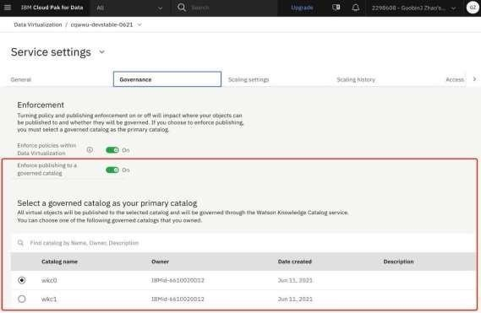

Bypublishingyourvirtualdatatoa catalog,youcan:

*Organize,label,classify,andsearch forthepublisheddataassetswithglobalsearch.

*Govern the virtual data asset and subject it to data protection rules by [enabling policyenforcementi](https://www.ibm.com/docs/en/SSQNUZ_4.5.x/svc-dv/enable-strict.html)nData

*Navigateto**Service settings**.

*Onthe**Governance** tab,enablethe**Enforcepublishingtoagoverned catalog**option.

AlistofgovernedcatalogsthatyouhaveAdminaccesstoisshown.You must select agovernedcatalogas yourprimary catalog.When yousetaprimary catalog, all

virtualizedobjectsarepublishedtothiscatalogautomatically.The**Publishtocatalog**

optionisdisabled whenyoureviewyourcartandvirtualizetables.

1. Ontheservicemenu,click**Virtualization** >**Virtualizeddata**.
2. Select the virtual objects that you want to publish and click **Publishtocatalog**.

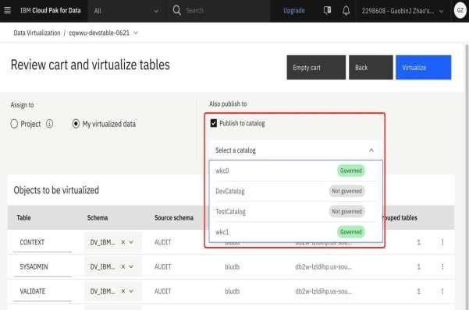

1. Continuewiththevirtualizationprocess